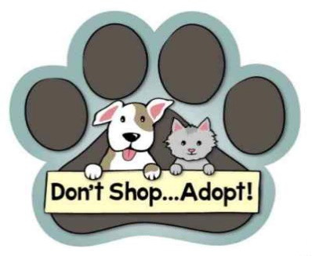
Doddridge County Humane Society, Inc.
1286 Wiseman Run
Salem, WV 26426
dchsfamily99@gmail.com
304-782-4900

ADOPTION CONTRACT

PLEASE PRINT CLEARLY:

Adopter’s Name: ____________________________________________ Date of Birth: _________________

Address, City, State, ZIP:

Home Phone: Cell Phone:

Work Phone: E-mail Address:

Names and ages of all persons living at your residence:

Veterinarian’s name and phone number:

How did you learn about this pet? ___Petfinder ___Facebook ___AdoptAPet ____Instagram

____Website ________________________Other (please describe)

List all pets (breed, age, and name) currently at your residence:

History of pets that have been in the residence in the past 5 years:

Type of Pet How Long Owned? Reason No Longer Owned

The welfare of the animal is our foremost consideration. The animals at our shelter have come from a variety of sources, so although we monitor and observe the animal’s health, we cannot guarantee it is not incubating a disease or illness. If the pet is too young to be spayed/neutered, proof of spay/neuter surgery is required by West Virginia law once pet is of appropriate age for surgery. Refusal to spay or neuter the animal will result in the sheriff taking the animal from you.

Our adoption fees are:
Dog: $125 mixed breed Cat: $100
$175 pure breed

In order to be considered as an adopter, you must be 18 years of age or older, present a valid driver license or photo ID, and consent to a brief background check to confirm no record of animal cruelty.

- I agree to provide proper food, clean water, adequate shelter, and kind treatment at all times.
- I agree to take the pet to a veterinarian for examination, immunizations, and treatment as needed, and if pet becomes ill or injured. I understand that if I am unable to provide needed medical or daily care, the animal must be surrendered back to Doddridge County Humane Society, Inc.
- I understand that a representative of DCHS, Inc. may, at any time, make a “well visit” to check on the animal, and if they deem it vital to remove the animal the Society may do so to ensure its welfare.
- If adopting a cat we expect you to not declaw your feline. This can damage them for the rest of their life.
- I understand that no refunds will be given after adoption.

Signature of Adopter Date

Signature of Humane Society Representative Date

Adoption of (name) ID No.

Payment Method/Check No. Amount

Rev. Jun 2024

